mmWave FMCW Radar-based Human Action Recognition

We are working on mmWave radar sensor for motion analysis. Below are the graphics of the test results made with mmWave Radar.

Sensor Calibration and Tests

The sensor configuration used in the testing and calibration shown in Figure 1.

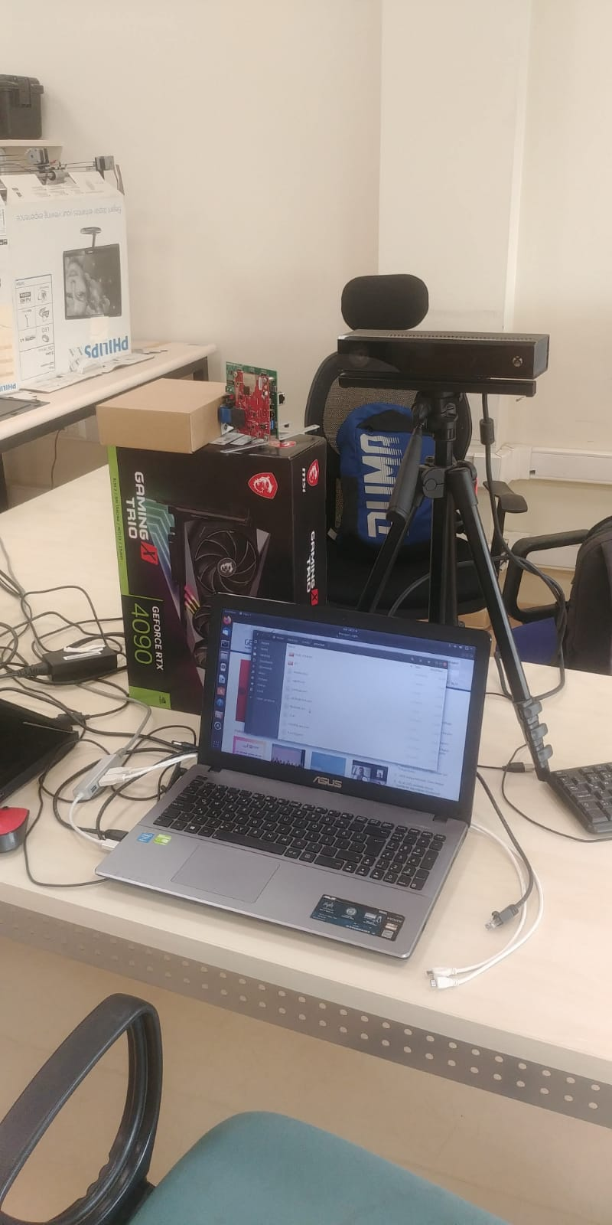 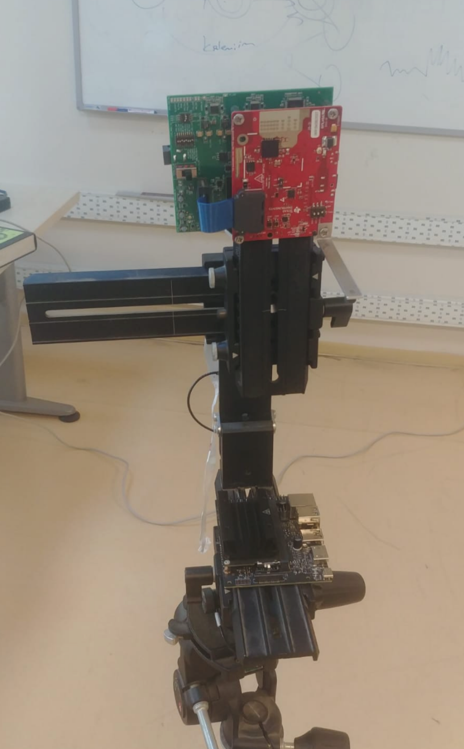 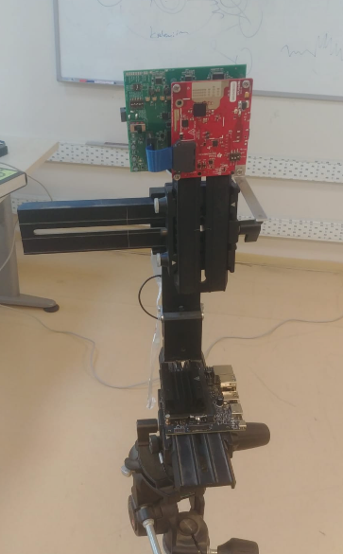

Figure 1 mmWave radar used in our tests. The radar has three transmitters and four receiver antennas.

We have done controlled tests to see if the pre-processing steps yield any useful information in the sensor data. Of course, the sensor data is visualized not in raw data but various forms of Doppler-Range images.

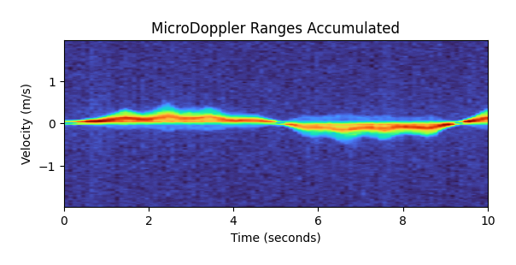

Figure 2 Micro-doppler of the sensor output observing a person moving towards and away from the sensor in a relatively periodic motion.



Figure 3 Micro-doppler of the sensor observing a person sitting on a chair and standing in a relatively periodic motion.

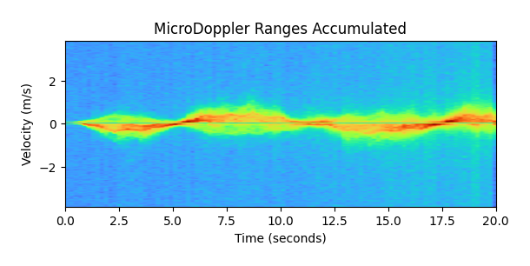

Figure 4 Movement of two people in opposite direction (towards sensor or away).

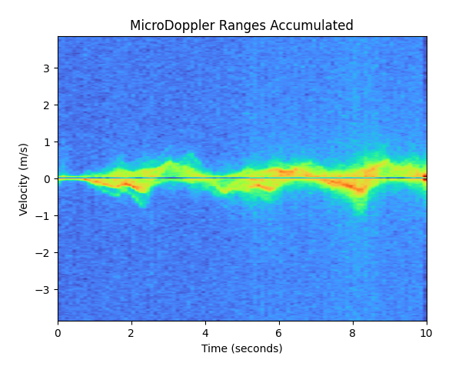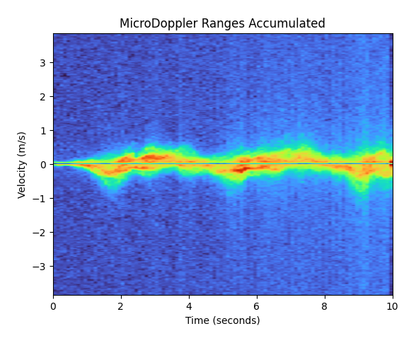

Figure 5 Moving parallel to the sensor (left: 1 person, right: two people).

 

Figure 6 The doppler-range version of the movement shown in Figure 5 (left: 1 person, right: two people).

These results (from Figure 2 to Figure 6) show that large motion can be seen in the doppler-range images well enough to classify the motion. The transformations will be applied to the collected data (explained in the next section).